Transcript:
ISAIAH KODONYO:“My name is Isaiah. I am also known as Kitikai son of Kodonyo. I have cows and goats. About 15 cows and around 50 goats and sheep.”
EUNICE MITAO:“My names are Eunice Mitao. I am 11 years old.”
The maasai are traditionally polygamous with old and young men taking up to three, four or more wives in their lifetime. The need for a second or third wife is not always for the man's satisfaction but for the good of the homestead and other women.
Isaiah kodonyo is no exception as he comes from a long line of polygamous families. Tomorrow morning he takes home a second wife, the only difference being this is not an arranged marriage.
ISAIAH KODONYO:“You cannot marry a woman you don’t love. You should marry a woman you love.”
Unlike his grandfather and father, Isaiah chose his second wife and unlike most maasai women, Eunice is happy to marry a man that she knows and loves.
EUNICE MITAO: “I am looking forward to tomorrow. I have always longed for this day. I am overjoyed.”
Due to his age Isaiah’s grandfather is respectfully called Mzee kodonyo. He is the Patriarch of the Kodonyo family with three wives, many children and plenty of grandchildren to carry his name.
MZEE KODONYO: “This is God’s blessing. I went looking for women to marry… And the Maasai gave them to me. I brought them into my home. I also brought wives for my son. I gave birth to Maasai children, girls and boys. I brought them all through the Maasai traditional marriage. “
“That is how my sons and I got married, using my goats and cows. So they are all mine.
I gave them alcohol and cows and they gave me their women.
Having just one wife is bad.”
“I would not have as many children and cows. If you want to have such a homestead, with plenty of food and maasai, one wife is not enough.”
Among all the wives in a maasai home, there is always the matriarch of the homestead, the first wife, from whom the home flourished. in this home, we meet Leah Kodonyo fondly called Gogo by her grandchildren.

Bridegroom, Isaiah


Bride, Eunice
LEAH KODONYO: "I brought all these children together."
"When I came from my father’s home, I was 15 years old. Since then, it has been many years."
"It is not the girl ho chooses the husband. It is the father who chooses for her. That is what happened to me. I did not choose."
The second wife to Mzee Kodonyo and Leah's junior co-wife, reflects on her wedding day as a young bride.
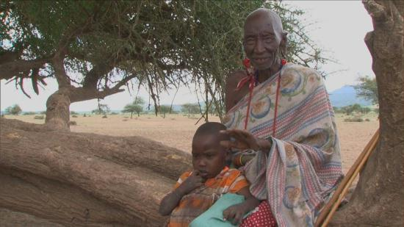
Isaiah's grandfather has three wives

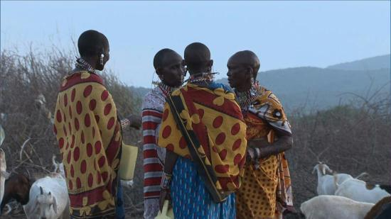
The wives
ESTHER KODONYO: "It was totally different in my time. When I got married, the man was so old. I was afraid to talk or greet him; I had to bow.""Nowadays, it is difficult to marry off a girl to an old man. They have to be young, like Eunice and Isaiah."
"I was given out to this old man by my father. We could not even shake hands, so he just used to greet me from a far."
LEAH KODONYO: "I hated it because I had a boyfriend, but I was afraid of my father. I broke up with my boyfriend and did what my father said."
"You cannot compare a boyfriend's love to a father’s love. A father's love is more important.
When your father chooses for you a partner, you have to respect that decision."
"I really loved my mboyfriend, like any other person would. When I was betrothed to Mzee Kodonyo, I broke it off and that was the end."
Contrary to popular belief, the polygamous nature of the maasai, is mainly perpetuated by the women. In most families, the reason for a second or third wife is due to the insistence of the first wife or the mother-in-law. The reasons are far and wide, the main one being that the wife needs more hands to handle the daily chores or is barren and would like a surrogate mother. In Leah Kodonyo’s case, however, she needed some extra help.
LEAH KODONYO: "I told him to bring this one and also the other one. My husband had a lot of cows."
ESTHER KODONYO: "She was always giving birth and had no one to assist her."
Isaiah's first wife is just as young as he is. Elizabeth Kodonyo is 23 years old and like any first wife in the maasai community, her status in the home is now of higher standing with the coming of a second wife.
ELIZABETH KODONYO: "I am happy that I am getting a companion. We will be staying together like sisters do. I am the first wife, so when the second one comes, I will be the one to give her the cows."
EUNICE MITAO: "Isaiah and I met at a shop in Embolei. Then we got to know each other better."
"I wanted to be the first wife, but I was late and now it is my turn to be the second wife."
ISAIAH KODONYO: "It was my father who helped me marry my first wife. I really need a second wife and I like how Eunice behaves. That is why I am marrying her."
"Today, the Maasai do not just keep cows, we also practice farming and that is why I need two wives."
"One will take care of the cows, and the other will look after the farm. So they both work together."
MZEE KODONYO: "Food brings people together. In this home we have many cows some of which have died Food brings people together."
"We live in harmony I this homestead because I am their father. There is no hatred, I am the one who married these three women. And they all love each other."
ESTHER KODONYO: "You may find us quarelling but we do not hate each other. We quarrel over small things, like someone taking your sugar without asking for permission. But it is only for a short time."
LEAH KODONYO: "When a man brings the first wife, he should bring another one.
We, the Maasai have many problems. Despite the problems, we do not hate each other. I do not mind seeing my husband going to my co-wife's house. Isaiah and Eunice are different because they love each other."
"Eunice was given to us by her parents in good faith. So, when Isaiah takes a third wife, they will still love each other."
"He did not take her by force. He ngave her family cows, blankets and sugar; so they love each other."
ESTHER KODONYO: "In our time, we never talked to the man, when you see him, you hide. Now, they agree first and then go ahead with the arrangements. The girl comes to see the home where she is been taken, like Eunice did. Even Isaiah went to the girl’s home. "
But we never had such arrangements.
LEAH KODONYO: "As a Maasai woman, it is important that you are married. According to Maasai culture, a woman cannot remain unmarried. Like us when you are 15 years old, your father gives you away. You need to get married and have children. A woman cannot stay without a husband and vice versa."
High afternoon in Ol Tepesi location, Eunice spends the few remaining hours before she is taken into her husbands home, with her grandmother.
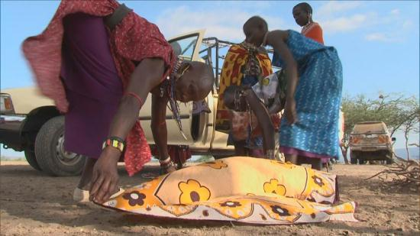
Preparation for wedding

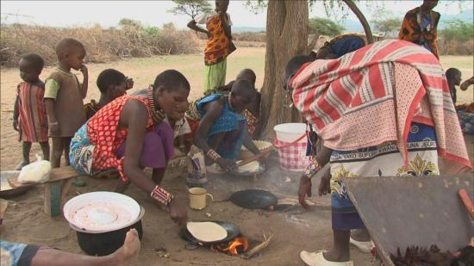
Cooking for wedding ceremony
RHODA NGUGUU: "I am going to pack all your things in the suitcase. I will pack your lotion and everything else needed."
"Go love your husband and love his mother because she is my age-mate. Love the home, love the first wife and your husband."
EUNICE MITAO: "I am not afraid because I am familiar with the Kodonyo family."
As tradition would have it, a young bride is sent off with a suitcase of her personal belongings and this is all she is allowed to bring with her to her new home.
RHODA NGUGUU: "I will put all these things inside. She will take it with her to her in-laws tomorrow. When she gives birth, he will give her children food in this plate. In this plate, she will give her husband food. These plates are for the guests. These are for ceremonies."
"During Christmas, she will serve everyone food."
EUNICE MITAO: "I will lock up all my shoes that so that no one can get them."
Saturday morning in Ol Tepesi and goat bells rings in the distance rather than the conventional wedding bells of such an occasion. Isaiah accompanied by his age mates and his father; arrive at Eunice’s home to claim their bride, having already presented their dowry of 5 cows and some blankets.
Like any other bride, Eunice is sprucing herself up ,with the help of her grandmother. the maasai women are very keen on fashion and decoration, using bright colors and jewelry to beautify themselves.
The bride puts on a light chain attached to her ear called Emonyorit. in this modern day that we live in, Eunice is quick to add a hair wig to her wedding regalia.
The grandmother helps to carry the suitcase which symbolizes the move from one home to the next, her new life as a wife. Isaiah's age-mates proudly take the suitcase and the marriage is sealed.
A long time ago, brides would walk for hours to reach their destination, the husband's home. today, Eunice is lucky enough to ride at the front seat of her father-in-law's vehicle.
While Eunice makes her way to her new home, the women of the Kodonyo family are hard at work preparing the afternoon meal for their guest.
ESTHER KODONYO: "In those days, everything was the same, except there were no cars."
"We came on foot slowly, until we reached the new home."
On their arrival, the Kodonyo family is at hand to welcome the new bride into the new home, lining the ground that she walks on with printed clothes called shukas.
The arrival of the new bride into the home is a time to feast on food and drink. Isaiah and his father Abraham are keen on choosing only the healthiest goat or sheep for the celebration.
ISAIAH KODONYO: "A man is always a man. One is not more or less, if you marry two wives or not. It is how you take care of your home. You give them equal responsibility,that is what a man is."
One takes care of the shamba and another takes care of the cows.
When all the food is ready, everyone takes his or her place. the maasai culture has for years maintained the social distance between men and women. according to them, it is considered disrespectful for a woman to eat in front of her husband or other elderly men. it is for this reason, even in ceremony of this nature that the women eat with the women and the men eat only amongst other men as culture dictates.
Later on in the evening, the women tend to their children and the goats, Isaiah and his age mates, gather in the matrimonial manyatta to welcome the shy bride. the men chant this maasai song in praise of the new bride while drinking their traditional beer.
The morning after the wedding is the beginning of a new life for Eunice who is no longer a guest, but a co-wife who has to share in the daily chores. Isaiah’s mother, plays the role of the mentoring mother-in-law to her young daughters-in-law by showing them how to be a good wife.
MARISA KODONYO: "Both Elizabeth and Eunice are still very young. Eunice does not mind being a co-wife. While Elizabeth still gets advice from me."
"When she woke up in the morning, she is no longer relaxing; we washed the dishes, we used last night. We sat together to prepare breakfast and we will cook lunch too."
"I am to teach them how to be a woman,how to take care of their animals, how to take care of their husband, and how to live together. Plus how to respect time; a woman does not go out roaming. By 4 pm, you have to be here, so that the small goats and calves are also cared for."
Maasai women always sit together, between their daily chores of looking after their children and livestock, to make their beaded jewellery. The next morning, we wake up to find Eunice doing exactly that, with the women in the kodonyo home. As she talks and laughs with them, making their beads, one would think she always belonged here. Today, she's no longer a new bride, she is one of them, and she is a co-wife.
Isaiah may love his second wife Eunice, but this love does not override the practicality of marriage among the maasai.
Barely a day passes, when Isaiah whisks Eunice off to his other home where they will reside with the livestock, she leaves with her husband to begin her new life, and fulfill her role as a wife.

